**MS**

**PowerPoint**

**Class Five**

**Lab 20**

|  |
| --- |
| Lab Objectives:  * PowerPoint Text Formatting |

# Adding A Text Box In PowerPoint

When adding text to PowerPoint presentations, many people limit themselves to using only the placeholder boxes that are present by default when you add a new slide.

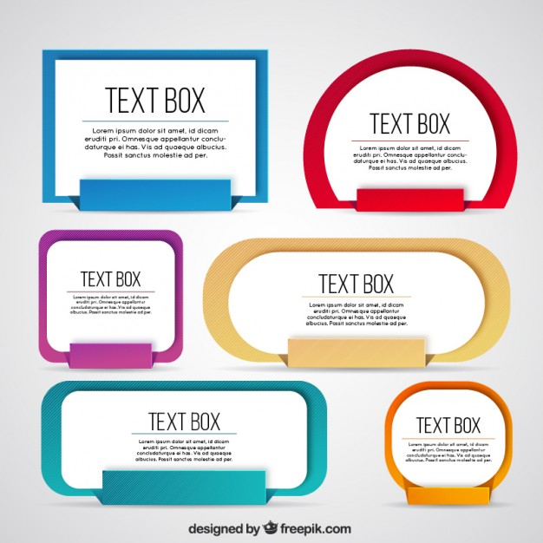For example, when you add a title and content slide, there is always a title placeholder in which you will see the words "Click to add title" and a content placeholder that displays the words "Click to add text". It's then a simple case of clicking into each of those boxes and then typing your content.

However, another way of adding text that gives you more flexibility over positioning is to add a text box. Click Insert > Text > Text Box, and the cursor will change to this shape:

IMG_256

Left click with the mouse and drag out the text box. Once the text box has been drawn, you can start typing in it. When you drag out your initial text box, it retains it's width, but the height contracts temporarily to be the height of one line of text. When you type multiple lines, the height will adjust to fit, but the width of the text box will remain fixed.

This is what the text box looks like:

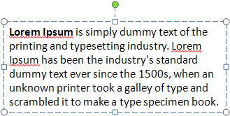

You can see resizing handles at each corner and also halfway along each edge. You can resize the text box by clicking and dragging on any of those handles.

# Moving A text box In PowerPoint

Moving a text box around in PowerPoint is as easy as drag and drop. If you are not careful, though, you will end up dragging the resizing handles. The first thing you have to do is select the text box as a whole. To do this position the cursor over one edge of the text box until you see a double headed cursor.



When you see the cursor change shape, click on the box. When the text box is selected, the dashed bounding lines become solid lines, as shown below.

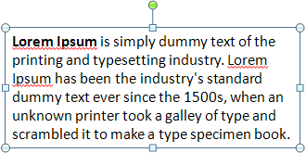

Now you can move the text box around either by clicking and dragging with the mouse, or by pressing the arrow keys on your keyboard.

# How To Format Text In PowerPoint

Most of the time, you will probably leave the text you type in your PowerPoint presentation as it is, without formatting it. However, sometimes you might like to style certain pieces of text so that it stands out.

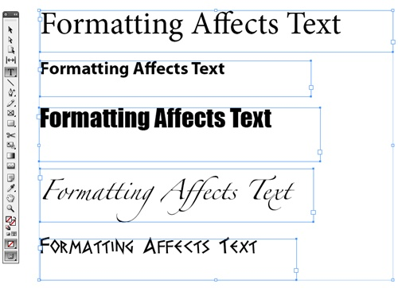

To format some text, first of all select it. As you move the cursor, the mini toolbar appears as if by magic. The mini toolbar contains some of the more commonly used formatting commands that PowerPoint guess you are likely to use. Using it, you can bold text, italicize it and do various other text formatting tasks, all at the click of a button. You will probably be familiar with all of the commands available on the mini toolbar, so we won't dwell on them.

IMG_256

If you want to apply more adventurous formatting, head over to the ribbon. When you select text, the Format contextual tab appears. On this tab are many different formatting functions. Let's get to grips with formatting text by running through a quick example.

Let's increase the font size and bold some text. To do that, all we have to do is select the text and then press ctrl-b. To increase the font size incrementally, press ctrl-shift->. You can keep pressing it until you get the right size, or select a specific font size from the ribbon. Click on the Format contextual tab and then click on the More button in Word Art styles.

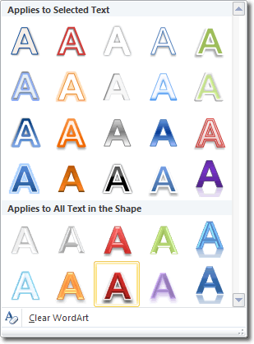

Pick a style that you like and click to apply it. Alternatively, hover over a style to see a live preview applied temporarily. When you move the mouse away from the style, the live preview is removed. This is what I came up with when I applied a Word Art style:



That looks pretty good!